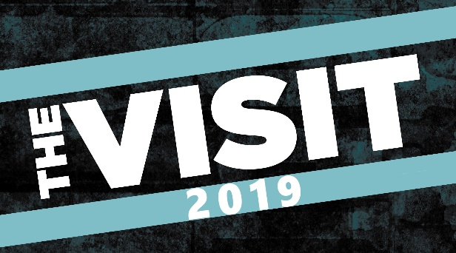
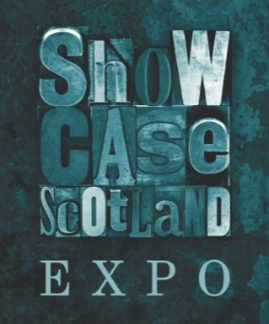
APPLICATION FOR SHOWCASE SCOTLAND EXPO MULTIPLE EVENTS

East Coast Music Association: 1 – 5 May 2019, Prince Edward Island, Canada.
- The Visit: 16 – 20 September 2019, Welcoming Southern Europe to Scotland
- English Folk Expo: 17 – 20 October 2019.

SHOWCASE SCOTLAND EXPO will present showcases at multiple events in 2019. In order to make the application process easier we are now opening applications to all of them, you are asked to tick the box below to indicate which events you are applying for. You can apply for all events. Information about each is below:

East Coast Music Association (ECMA) – Held in Prince Edward Island, this is a significant gathering of Canadian festivals and venues, one of the largest in Canada. Delegates also attend from overseas and come from pockets of Europe as well as the USA. Each performer will be paid a small fee by the festival and your hotels are covered for two nights, backline will also be provided. Two artists will be selected. Relevant if you are keen to develop the North American markets.

The Visit 2019 will focus on Southern Europe. Falling in the months after Brexit, it is extremely important that we continue to build relationships with our European partners. In 2019 we will focus on Europe (south of Germany) plus the Netherlands and Belgium and in 2020 Northern Europe (Germany and North), there will also be delegates from Eastern Europe attending both. A £30 performance expense will be provided to each musician and concerts will be taking place at Perth Concert Halls and Edinburgh Queen’s Hall. Some of these concerts will be open to the public and the venues will directly discuss with each artist a performance fee for these shows. The delegates are comprised of festivals, venues and agents. Previous editions of this event have been hugely successful resulting in Scottish focuses at the Lorient festival in France as well as the Rudolstadt Festival in Germany. Multiple agency deals have been secured and numerous international performances achieved. Twenty one artists will be selected. Relevant if you are keen to develop South of Europe markets including the France, Italy, Spain and Portugal, and also the Netherlands and Belgium,

English Folk Expo takes place during the Manchester Folk Festival. Each act will be offered a paid performance as part of the festival and you will be responsible for covering your travel within this fee. The Festival will also provide one night’s accommodation for you on the day of your performance. Each artist will also perform a short set as part of a 2 hour Showcase Scotland reception. Backline and production will be provided. Four artists will be selected. Relevant if you are keen to develop predominantly the UK market.

We are seeking applications from artists to be selected to perform as part of these events. The application form below should be completed and emailed along with any supporting materials to showcasescotland@activeevents.org.uk by 5pm on Monday 14th January 2019.

Guidance Notes

- Artists’ work must be rooted in the acoustic, folk, Gaelic, roots, Scots language, traditional, or world music genres.
- For the ECMA and Visit showcases, artists will have a demonstrable track record of performance in the UK including e.g. live reviews, festival and venue performances.
- For English Folk Expo, artists will have a demonstrable track record in Scotland. If any touring has been undertaken in England then please make sure you list it.
- Artists must be able to demonstrate the ability to maximise the promotional opportunities that Showcase Scotland Expo affords e.g. strong web and social networking presence, credible mailing lists, promotional product for the event, EPK/Live footage available.
- Artists must be able to articulate their rationale for applying and relevance to their career.
- Artists must be willing to undertake press interviews etc as required for the Showcase Scotland Expo showcase.
- Artists must be able to provide access to three tracks by providing a soundcloud link.
- Evidence of existing international interest or support is desirable.
- Artists must be available to perform on the dates listed above.
- Artists must agree to provide evaluation as required to the Showcase Scotland Expo Steering Group. This will include financial information regarding onward bookings secured from the Showcase.
- Artists must be resident in Scotland.

Applicants are asked to complete the application form and return to showcasescotland@activeevents.org.uk by 5pm on Monday 14th January 2019

APPLICATION FORM

Please mark with an x which events you are applying to showcase at:

The ECMA Canada (1 – 5 May 2019)

The Visit (16 – 20 September 2019)

English Folk Expo (17 – 20 October 2019)

- APPLICANT'S DETAILS

Name of artist:

Name of agent/manager (if applicable):

Contact address:

Postcode:

Telephone contact number:

Email contact address:

Website (artist/agent(s) or both):

Are you a full time professional musician?

How many musicians are part of your permanent ensemble?

Do you perform in any musical ensembles other than that named on this application? (If yes please list)

Dates you are available to perform at each event.

- ARTISTIC WORK

Please describe your work and why you consider it is rooted in acoustic, folk, Gaelic, roots, Scots language, traditional, or world music genres. It will be essential to meet this criterion (250 words maximum).

Please provide soundcloud links to three tracks of music below.

- EXPORT READY

Please detail up and coming live performances in the next 12 months (confirmed or under discussion). If you run out of room you can attach a separate sheet.

Please give details of all (or most significant) UK performances over the past two years e.g. venue/festival, date, headliner or support (if the latter, please name the main artist).

Please give details of all international performances over the past two years.

- PROMOTION

Please provide details of your current marketing and PR activities support. This should include information on whether you are self-marketing; supported with details of press agents and PR companies if relevant and the numbers on your mailing lists.

- MARKETING

In addition to your website details, please provide information on other forms of internet marketing and networking you use with relevant addresses e.g. Facebook, Twitter, Youtube channel, etc.
Where applicable please indicate the number of “likes" and “followers” you have. Please also list numbers of streams and if you can, which location the streaming has taken place (i.e. town or country)

Please provide a link to your EPK or attach with your application (if the latter put 'attached' in the box below).

Please provide information about your most current/future albums e.g. title, when released, availability and information and links to press reviews. Please indicate the territories that you have released/plan releases in, with details of record labels/distributors where applicable.

- CAREER RELEVANCE

Please outline why you want this opportunity to perform at an international showcase. Why is this opportunity relevant for your career ambitions; what do you expect to gain from such an experience; and how will you evaluate success? (250 words maximum).

Please tell us if you are self-managed or provide agent/manager details in the UK and overseas markets.

- TECHNICAL REQUIREMENTS

Please include your technical specifications, stage plan and channel list below or attach with your application (if the latter write 'attached' in the box below).

Applicants are asked to complete the application form and return by email to showcasescotland@activeevents.org.uk by 5pm on Monday 14TH January 2019 together with a soundcloud link to 3 tracks that the artist considers best represents their work, an EPK and technical specification/channel list.

If you have any queries prior to emailing your application please email showcasescotland@activeevents.org.uk with ‘Showcase Expo’ in the subject line.

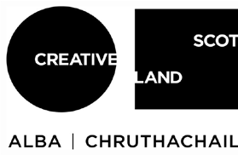
Showcase Scotland Expo c/o Active Events
The Courtyard
22 Hayburn Street Glasgow
G11 6DG

